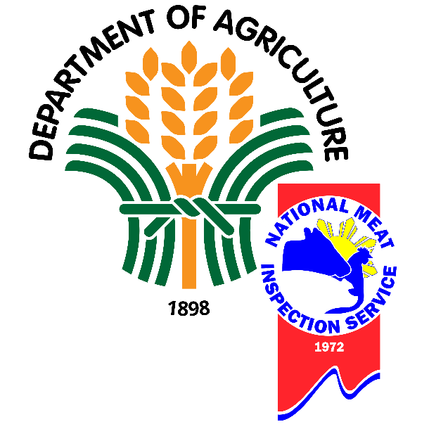

**Automated In-Plant Line Inspection Reporting Systems**

**(AIPLIRS)**

User’s Manual

Table of Contents

**POSMD Account** 4

DASHBOARD PAGE 4

POSMS Accounts 5

Modification of POSMS Account 5

Approval of POSMS Account 6

Disapproval of POSMS Account 6

Deactivation of POSMS Accounts 7

Activation of POSMS Account 8

Meat Inspection Officer Accounts 8

Meat Inspection Officer Accounts List 9

Meat Inspection Officers profile 9

Current Meat Establishment Assignments 9

Introduction

# POSMD Account

POSMD account is a super admin of the system who can do anything inside the system and can view national, regional, and municipality/city data. And can view and modify different accounts such as POSMS accounts, MIO Accounts, and ME accounts. POSMD can add and update diseases or conditions through system that will be reflected on the inspection

POSMD Account has a different page can be accessed at the sidebar of the page here is the list:

* Dashboard
* POSMS Accounts
* Meat Inspection Officer Accounts
* Meat Establishment Accounts
* Disease or Conditions
* Receiving of Animals
* Fit for Slaughter
* Fit for Human Consumption
* Condemnation Report
* Meat Inspection Summary

## DASHBOARD PAGE

The Dashboard page shows the summary of the following reports from the first month of the year (January) to the present date. As shown in the following figures:

* **Total Number of animals received** – In this figure shows the total number of received in all meat establishments nationwide *(Figure 1)*
* **Total Number of animals slaughtered** - In this figure shows the total number of passed for slaughter in all meat establishments nationwide *(Figure 2)*
* **Total Volume of Meat fit for human consumption** - - In this figure shows the total number of fit for human consumption inspected by Meat Inspection Officers in all meat establishments nationwide *(Figure 3)*

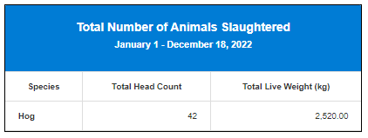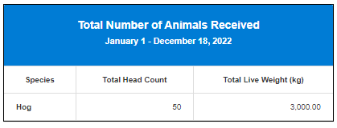

Figure 1 Figure 2

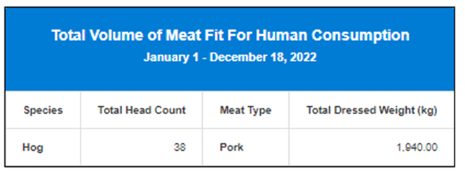

Figure 3

## POSMS Accounts

On this page, user can modify POSMS Account upon registration **Approve / Disapprove** and for the account status can **Activate / Deactivate**. It will show the details of POSMS account

Figure 1: In this figure, it will show the full information of POSMS accounts (Personal Information, Account status, Action)

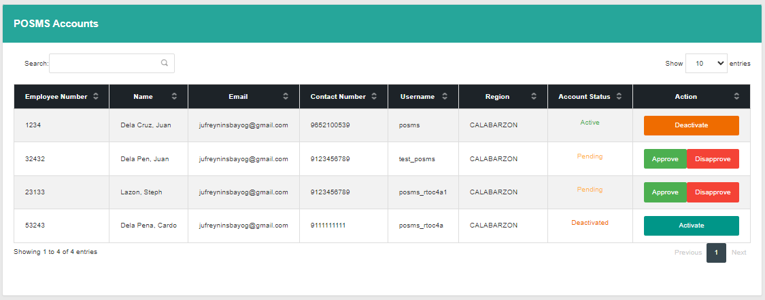

Figure 1

### **Modification of POSMS Account**

In modification of POSMS Account user can:

* Approve
* Disapprove
* Deactivate
* Activate

### 

### **Approval of POSMS Account**

Step 1: Clicking button of “Approve”

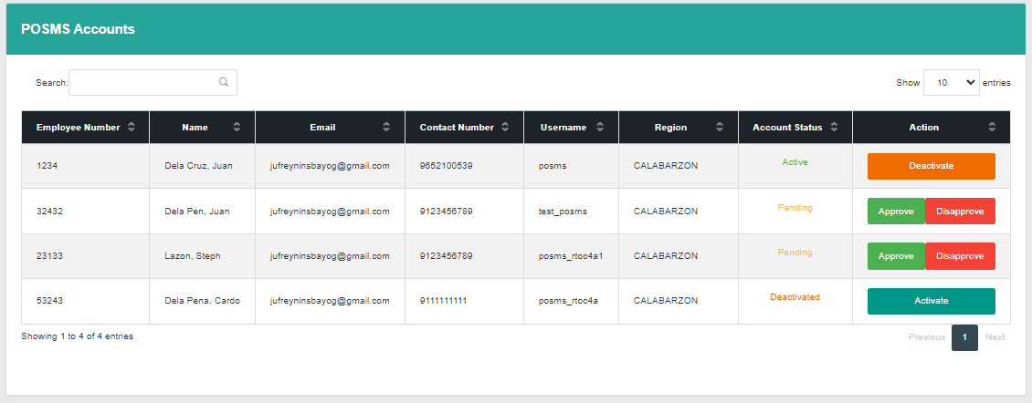

“Approve” button

Step 2: After clicking button “Approve” prompt will pop up to response if yes or no

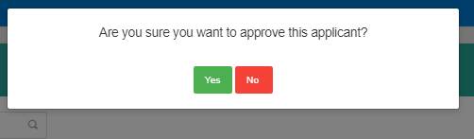

Step 3: After approval applicant will be able to login

### **Disapproval of POSMS Account**

Step 1: Clicking button of “Disapprove”

“Disapprove” button



Step 2: After clicking button “Disapprove” prompt will pop up to response if yes or no but this time user required to fill up the remarks for the reason of disapproval.

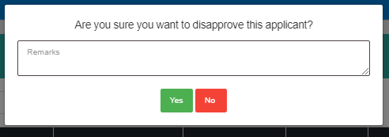

Step 3: Remarks will send to the gmail that applicant provided by upon registration.

### Deactivation of POSMS Accounts

Step 1: Clicking button of “Deactivate”



“Disapprove” button

Step 2: After clicking button “Disapprove” prompt will pop up to response if yes or no.

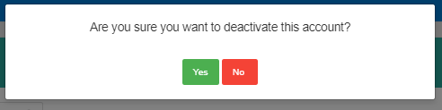

Step 3: POSMS Account will be deactivated and have no longer access through system.

### Activation of POSMS Account

Step 1: from deactivated account user has an access to re-activate the deactivated account, by clicking “Activate” button

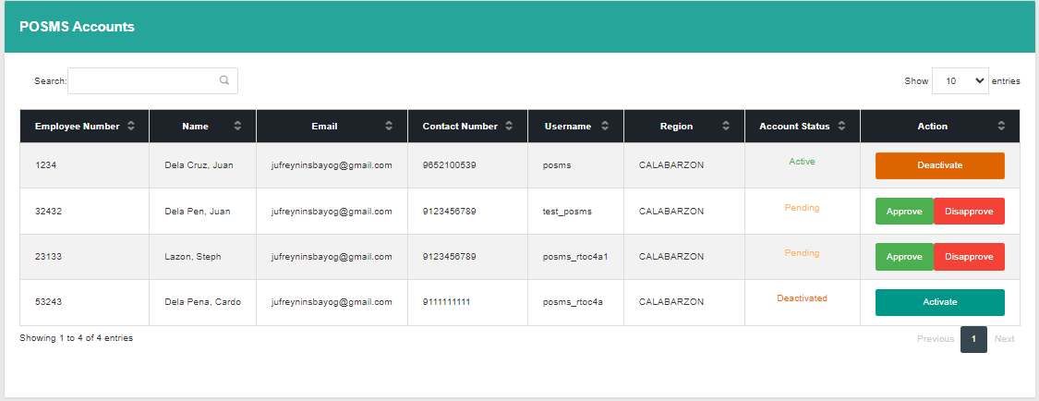

Step 2: After clicking “Activate” button prompt will pop up that will response to yes or no question.

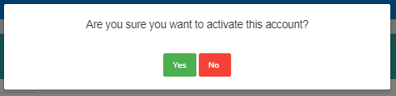

Step 3: the deactivated account will be activated and can login through system.

## Meat Inspection Officer Accounts

In this page user can view the list of Meat Inspection Officers profile

* Meat Inspection Officers list
* Meat Inspection Officers profile
* Current Meat Establishment Assignments
* Previous Meat Establishment Assignments
* Meat Inspection Activities

### Meat Inspection Officer Accounts List

In this page it shows the list of Meat Inspection Officer list with their status and view details button.

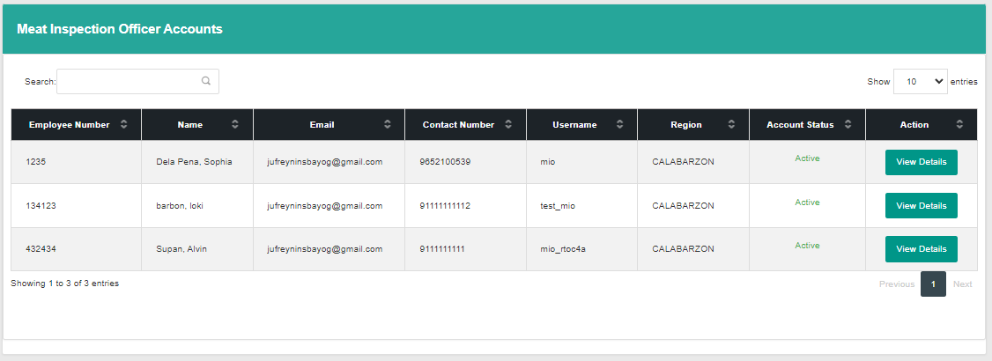

### Meat Inspection Officers profile

### It shows the personal information of Meat Inspection Officer

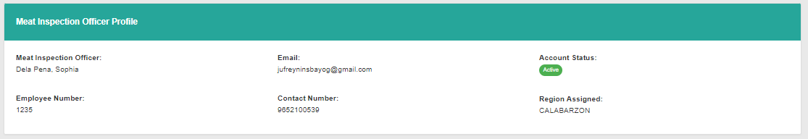

### Current Meat Establishment Assignments

It shows the current meat establishment where Meat Inspection Officer is assigned

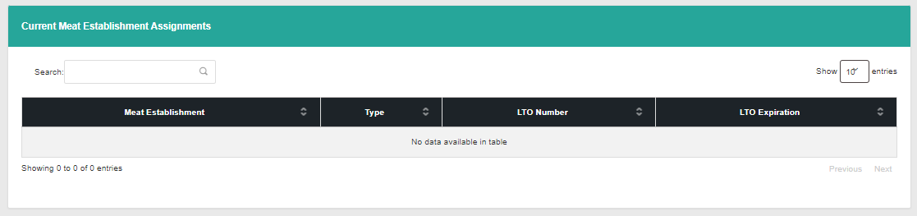

### Previous Meat Establishment Assignments

It shows the previous meat establishment where Meat Inspection Officer is assigned and it shows the date range of his service from start date and end date, Region assigned

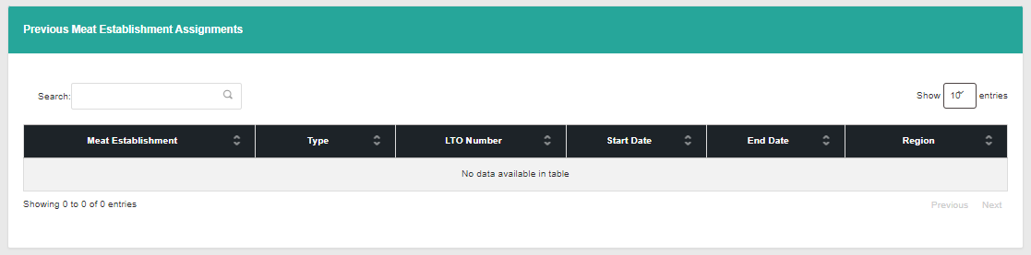

### Meat Inspection Activities

It shows the conducted condemnation of Meat Inspection Officer in every meat dealer it indicates on what meat establishment, date of condemnation, region, species such as Antemortem and Postmortem inspection.

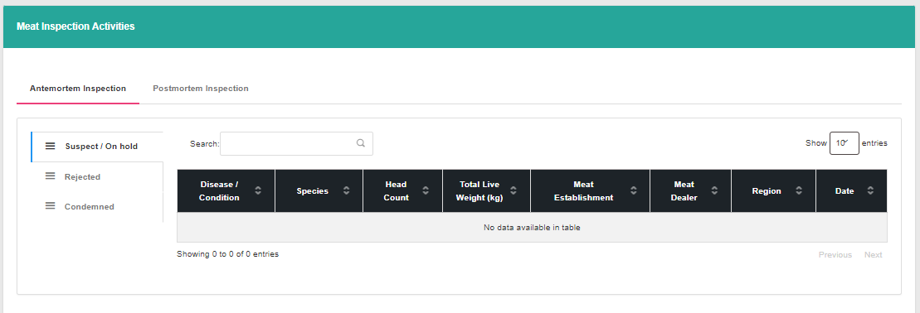

## Meat Establishment Accounts

In this page it will show the list of meat establishment registered to system, it indicates on the table information of meat establishment and its status especially the expiration date of their license to operate and it will display the assigned meat inspection officer

* Meat Establishment list
* Meat Establishment profile
* Current Meat Inspection Officer Assigned
* Previous Meat Inspection Officer Assigned

### Meat Establishment list

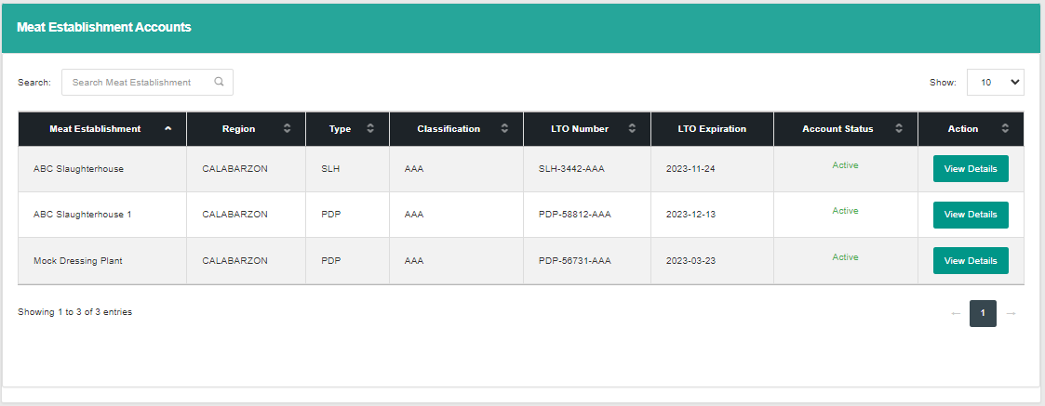

### Meat Establishment profile

It shows the information of the meat establishment

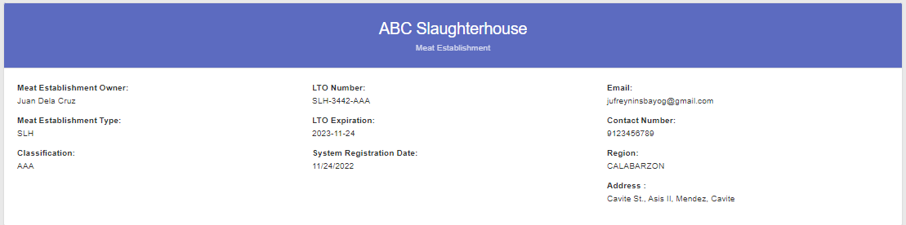

### Current Meat Inspection Officer Assigned

It shows the Meat Inspection Officer assigned

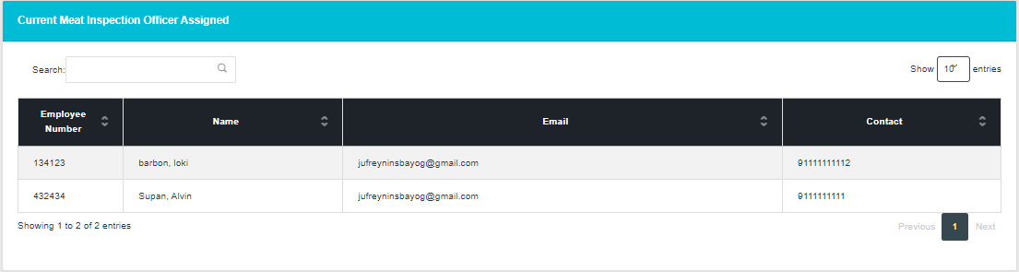

### Previous Meat Inspection Officer Assigned

It shows the previous meat inspection officer assigned in this meat establishment

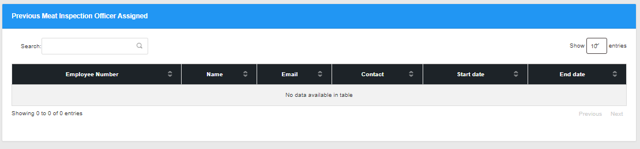

## Disease or Condition Page

In this page it shows the list of disease or condition, while user can modify diseases or condition, can add, edit and delete disease or condition.

* Antemortem Disease or Condition List
* Postmortem Disease or Condition List

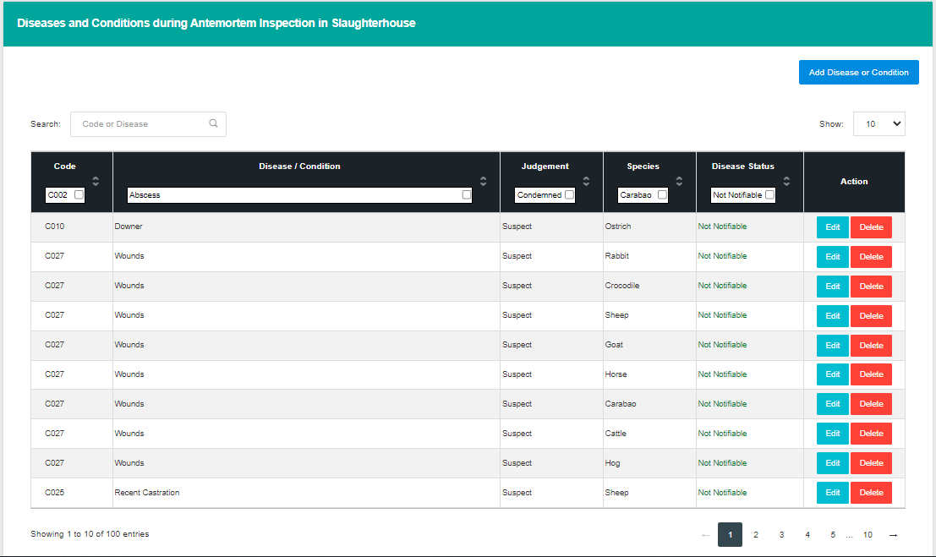

### Adding of Antemortem Disease or Condition

Step 1: On the sidebar choose disease or condition

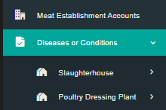

Step 2: choose if that specific disease is for slaughterhouse or for poultry and choose if for Antemortem and Postmortem

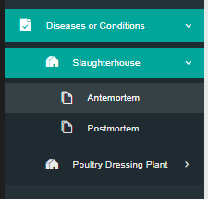

Step 3: it will redirect user to the other page and click “Add Disease or Condition” button

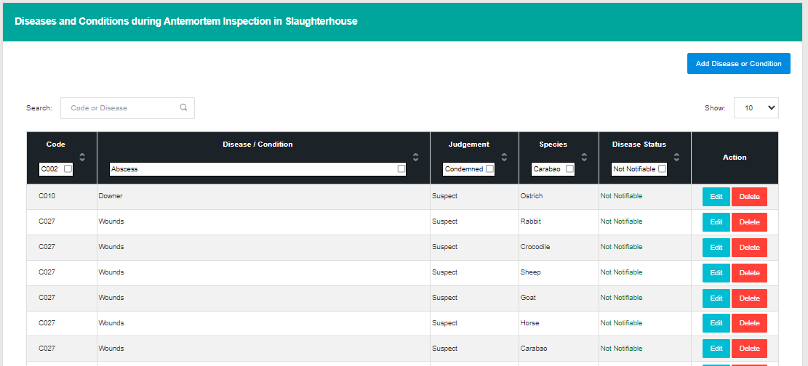

Step 4: pop up form will be appear and fill up the necessary fields.

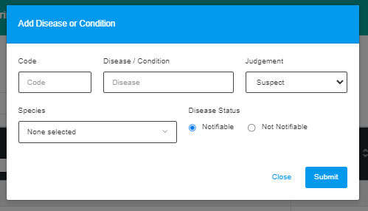

Step 5: Click submit to save the disease or condition.

### Update Disease or Condtion

To update disease or condition user will modify it on the same page. This time user will select the row that he / she want to update

Step 1: Choose a row that will be update then click “Edit” button



Step 2: After choosing a row and clicking a edit button pop up form will be appear, user will fill up the fields

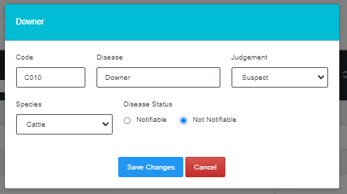

Step 3: After filling out the form click “Save Changes” to save changes.

## MEAT INSPECTION REPORT

In this page it shows the summary of each category, user can filter by Starting date and ending date such as Daily, Weekly, Monthly and Yearly.

**Categories**

* **Receiving of Animals** – in this page it will show the summary of the received animals by the meat establishment, user can filter:
  + By National Data
  + By Meat Establishment Data
* **Fit for Slaughter** – In this page it will show the summary of total number that passed for slaughter inspected by the Meat Inspection Officer, user can filter:
  + By National Data
  + By Meat Establishment Data
* **Fit for Human Consumption** – In this page it will shows the summary of total number that fit for human consumption inspected by Meat Inspection Officer, user can filter
  + By National Data
  + By Meat Establishment Data

### Receiving of Live Animals

**By National Data**

Step 1: to access the “Receiving of animals” by national data. Click on the sidebar has a label “Meat Inspection Report” then click receiving of animals it will dropdown and choose national data

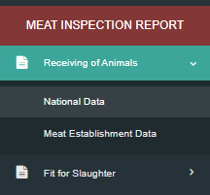

Step 2: After Clicking Receiving of animals by national data it will redirect user to the page that can filter

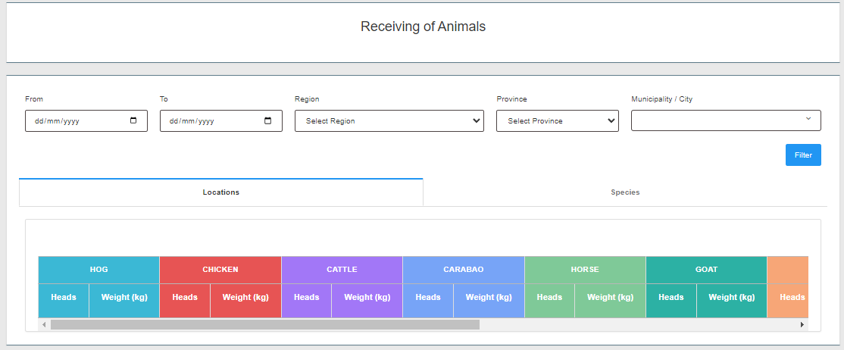

Step 3: In this page it has a dropdown for the selection of from date(starting date), to date(ending date), Region, Province and Municipality / City to filter result specifically. After selecting details on dropdown user need to click “Filter” button to show the result on the table under the dropdown

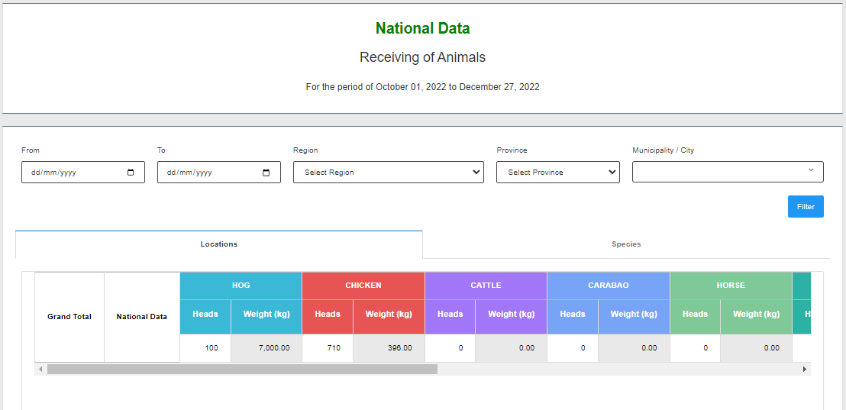 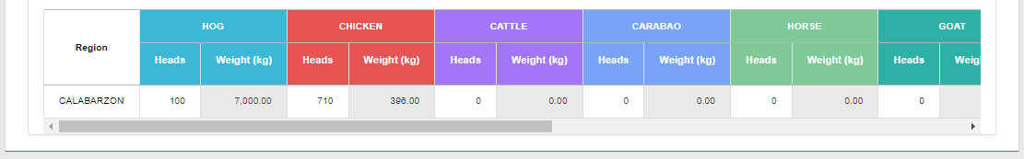

In this page has 2 tabs one for “Location” and the other is “Species” in this tabs it will show the summary of total number.

* Location : in this tab it will show the total number of data based on what user filtered



* Species: in this tab it will show the total total number of Species

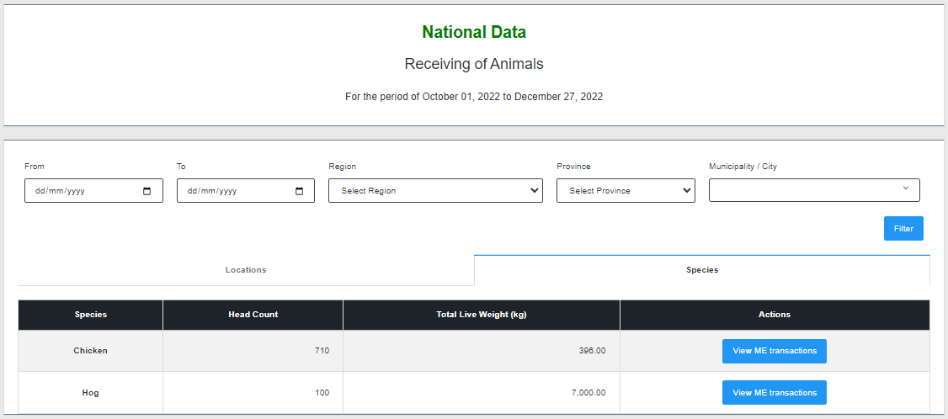

**By Meat Establishment**

Step 1: On Receiving of Animals dropdown choose Meat Establishment

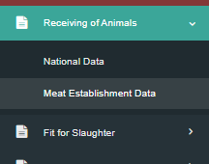

Step 2: After Clicking Receiving of animals by Meat Establishment Data it will redirect user to the page that can filter specific Meat Establishment

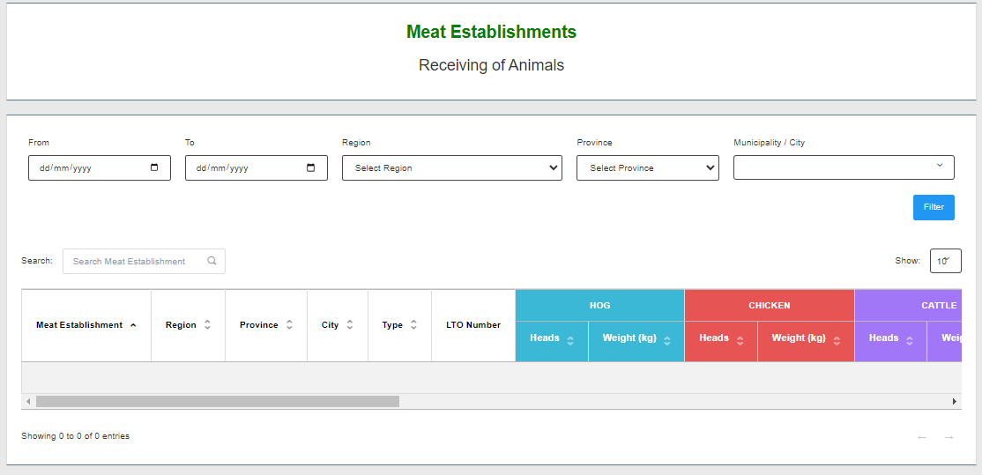

Step 3: In this page it has a dropdown for the selection of from date(starting date), to date(ending date), Region, Province and Municipality / City to filter result specifically. After selecting details on dropdown user need to click “Filter” button to show the result on the table under the dropdown

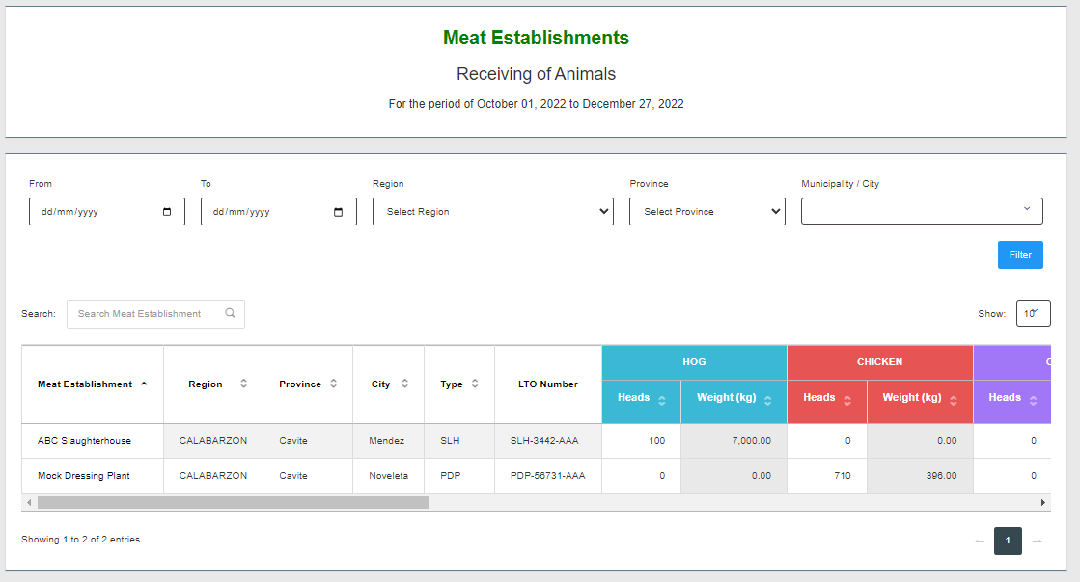

### Fit for slaughter

**By National Data**

Step 1: to access the “Fit for slaughter” by national data. Click on the sidebar has a label “Meat Inspection Report” then click Fit for Slaughter it will dropdown and choose national data

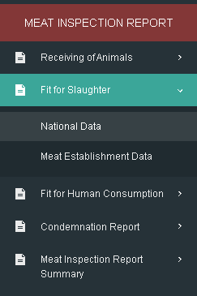

Step 2: After Clicking Fit for Slaughter by national data it will redirect user to the page that can filter



Step 3: In this page it has a dropdown for the selection of from date(starting date), to date(ending date), Region, Province and Municipality / City to filter result specifically. After selecting details on dropdown user need to click “Filter” button to show the result on the table under the dropdown

 

In this page has 2 tabs one for “Location” and the other is “Species” in this tabs it will show the summary of total number.

* Location : in this tab it will show the total number of data based on what user filtered



* Species: in this tab it will show the total total number of Species



**By Meat Establishment**

Step 1: On Receiving of Animals dropdown choose Meat Establishment



Step 2: After Clicking Receiving of animals by Meat Establishment Data it will redirect user to the page that can filter specific Meat Establishment



Step 3: In this page it has a dropdown for the selection of from date(starting date), to date(ending date), Region, Province and Municipality / City to filter result specifically. After selecting details on dropdown user need to click “Filter” button to show the result on the table under the dropdown

